Project Initialization and Planning Phase

Date | 02 February 2026
Team ID | LTVIP2026TMIDS65523
Project Name | Gemini Historical Artifact Description
Maximum Marks | 3 Marks

Define Problem Statements (Customer Problem Statement Template):


Understanding historical artifacts requires extensive research, expert knowledge, and access to reliable historical sources. Many historians, students, museum curators, and content creators spend significant time gathering information and crafting detailed descriptions of artifacts. This process can be timeconsuming and may limit the accessibility of historical knowledge to a wider audience.Additionally, generating engaging and informative content that accurately reflects the historical significance, cultural context, and material details of artifacts is challenging without specialized expertise.To address these challenges, there is a need for an intelligent system that can automatically generate high-quality historical descriptions while reducing manual effort.The problem is to develop a web-based application that leverages Generative AI to produce detailed, accurate, and engaging descriptions of historical artifacts based on user input such as artifact name or historical period. The system should enhance productivity for researchers and educators while making historical information more accessible to everyone.

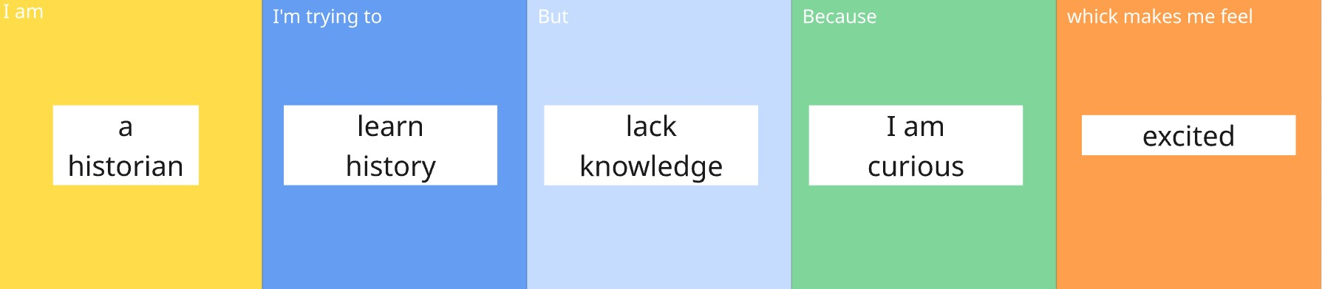

Problem Statement (PS) | I am  (Customer) | I’m trying to | But | Because | Which makes me feel
PS-1 | a historian | learn history to better understand historical artifacts | lack  knowledge | I am curious | excited

